Waiver/Program User Manual

A step by step navigational process

January 2014

Prepared by FEi Systems

Table of Contents

1 Getting Started 1

2 Tutorials 1

2.1 Application Module 1

2.1.1 Freedom of Choice Form 2

2.1.2 Application Information Form 5

2.2 Individual Cost Neutrality 9

2.3 Assessment and Plan of Care 11

2.4 Level of Care 15

2.5 Plan of Service 16

2.6 Authorization to Participate 16

2.7 Financial and Overall Decision 24

2.8 Letters 25

2.9 Appeal and Disposition 26

2.10 Case Notes 26

2.11 Activities 28

3 Appendix 35

3.1 Waiver/Program Connections with Other Modules 35

# Getting Started

This manual gives an in depth navigational walk through of the application process for Waiver/Programs from the standpoint of Support Planning Agencies. Where applicable the Tutorials will call out the functions Support Planning Agencies are capable of performing and in other sections will identify if they have list and view only access. Also, within each section the Tutorials will explain the in-depth business rules and interconnections between modules within the Waiver/Program application process.

# Tutorials

## Application Module

The first step in accessing the Application module is to search for the client under the Clients tab in LTSS. After entering search criteria click the Cases button in order to produce a list of clients that match the search criteria. After identifying the client record you wish to access, click the Client Summary link as shown in the figure below.

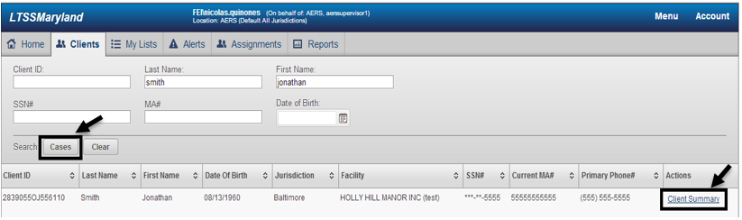

After clicking the Client Summary link, the user will be taken to the Client Summary page of the respective client selected. To access the Application module from the Client Summary page, click on the Programs tab in the left hand navigation and then select Applications under the submenu as seen in the figure below. Please note the before being able to perform the functions authorized to Support Planning Agency users, your Support Planning Agency must be actively assigned to the individual. Refer to the SPA Selection User Manual for details on assigning a Support Planning Agency to an individual.

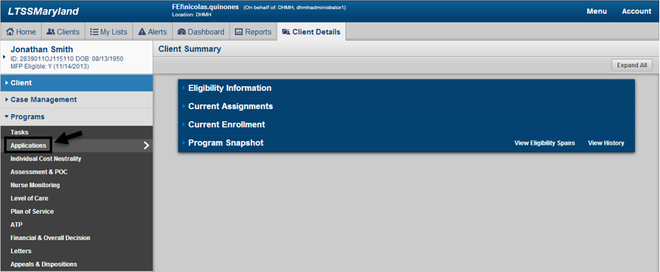

### Freedom of Choice Form

After accesing the Applications module a list of Freedom of Choices Forms across the entire history of the client will be available as seen in the figure below.

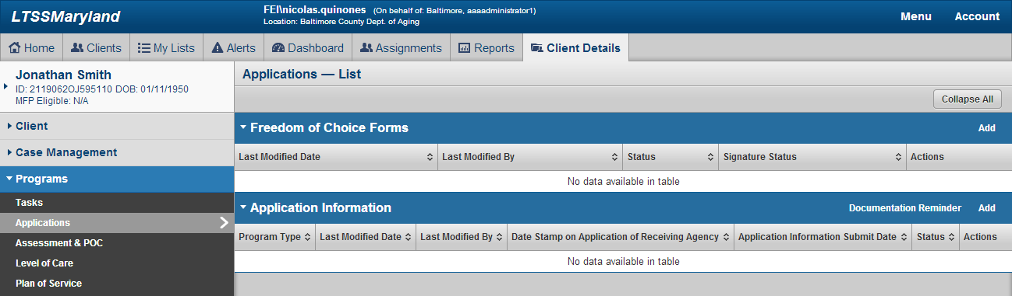

The user can add a Freedom of Choice Form by clicking the Add link as seen in the figure below.

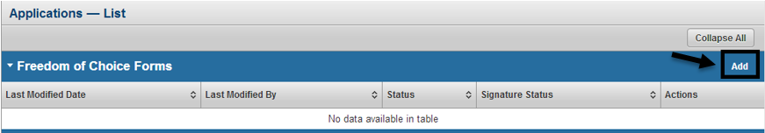

To add a Freedom of Choice Form fill out the required information and click the Save button as seen in the figure below.

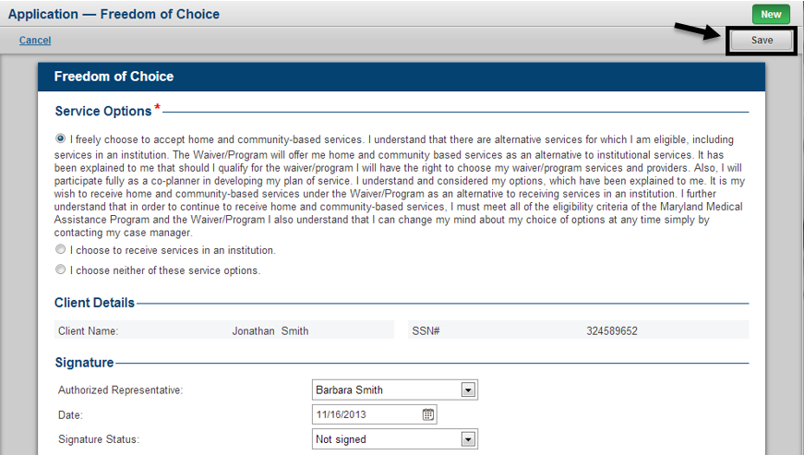

After saving the Freedom of Choice Form the user can go back and edit information within the form as long as the form is in a status of In Progress by clicking the Edit button as seen below. Once the user is ready to submit the form, click the Submit button as seen in the figure below.

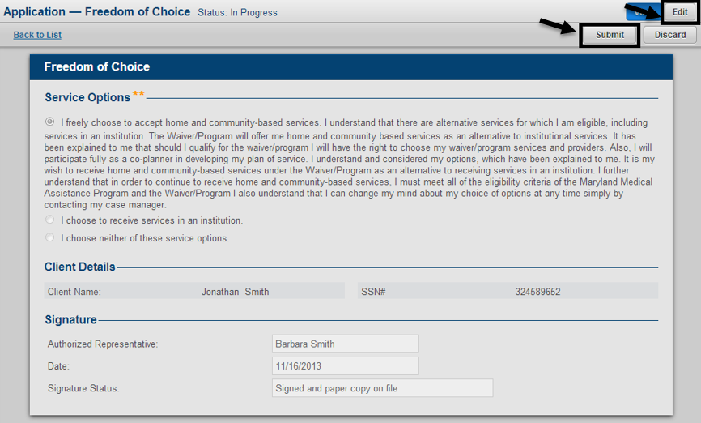

Once the Freedom of Choice form has been submitted, the status of the form will change to Submitted and the user will no longer be able to make edits to the document.

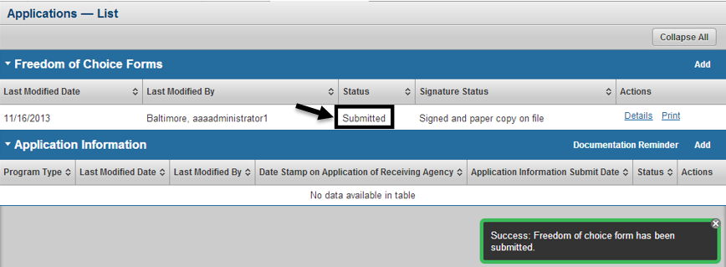

Authorized users will have the ability to discard a Freedom of Chioce form at any time when it is in a status of In Progress or Submitted. To discard the Freedom of Choice form click the Discard button as seen in the figure below.

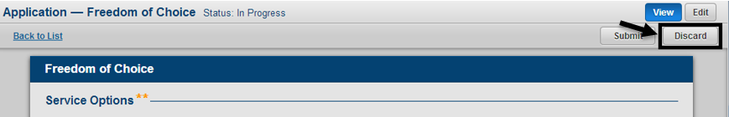

When choosing a discard a Freedom of Choice form the user will be prompted to enter comments and confirm that they wish to continue with the discard of the form as seen in the figure below.

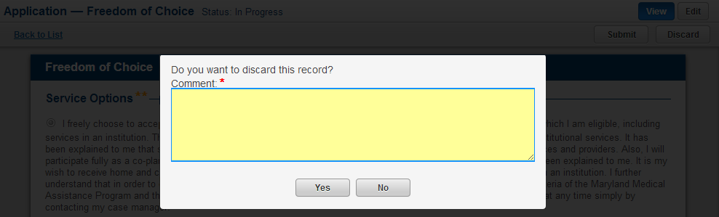

After entering comments and confirming the discard, the status of the Freedom of Choice form will change to Discarded and the user can view the comments related to the discard by clicking the icon in next to Discarded within the Status column in the Freedom of Choice Forms table.

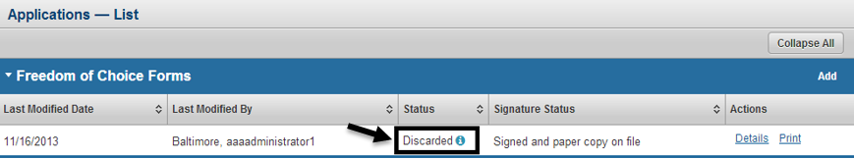

After adding a Freedom of Choice form the user can view the information for a specific form by clicking the Details link as seen in the figure below. Authorized users can also generate a custom print for the form as a PDF by clicking the Print link.

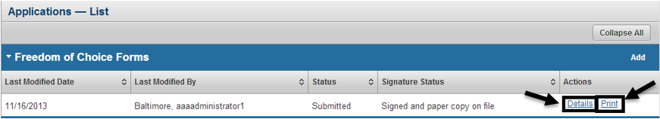

### Application Information Form

From the Application module within LTSS, authorized users will also have the ability to work with the Application Information form. To add the Application Information form click the Add link as seen in the figure below.

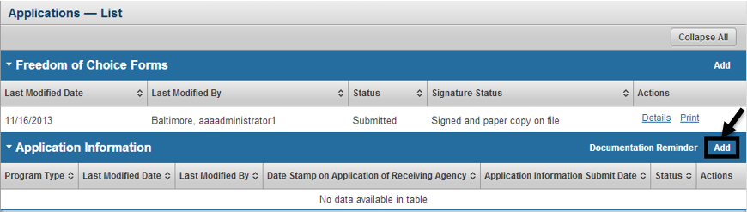

The Application Information form can be utilized for the Community Options Waiver (CO) and for the Increased Community Services Program (ICS). When adding the Application Information form the user will be prompted to select the program association as seen in figure below.

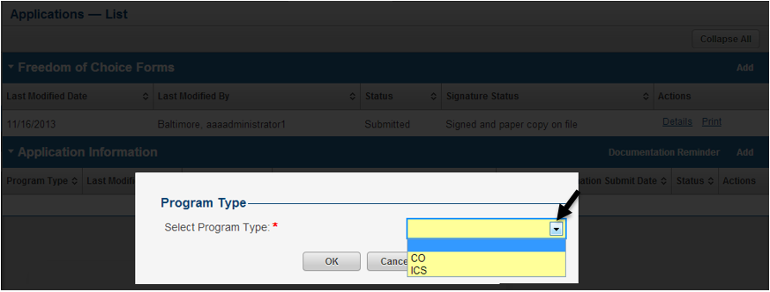

After selecting the Program Type of the Application Information form and clicking OK, the user will be taken to the form. After entering all required and optional information the user can complete the form by clicking the Save & Submit button as seen in the figure below.

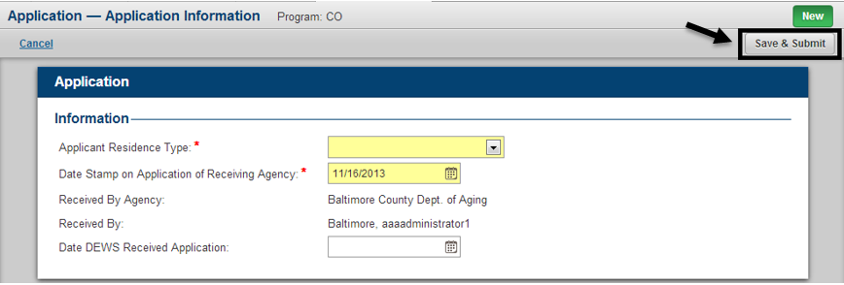

One unique feature of the Application Information Form will be that authorized users will have the ability to go back and update the Date DEWS Received Application at any time for this form. To update this field click the Update link as seen in the figure below and then make any necessary updates.

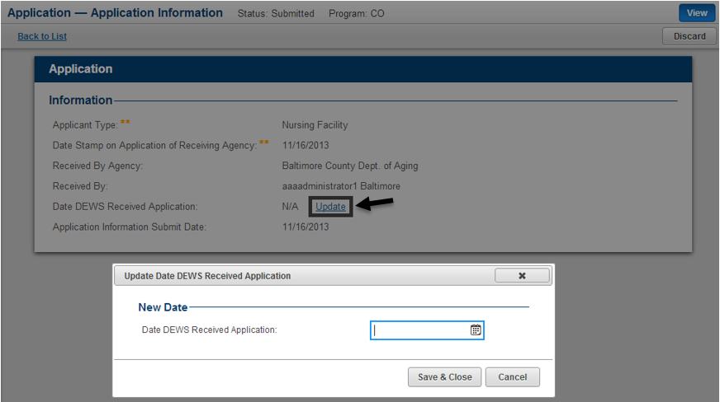

After submitting the Application Information form the form will be added to the Application Information table within the Application module in a status of Submitted as seen in the figure below.

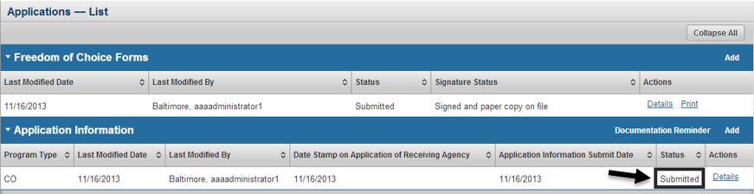

Authorized users will have the ability to discard an Application Information form by clicking the Discard button as seen in the figure below.

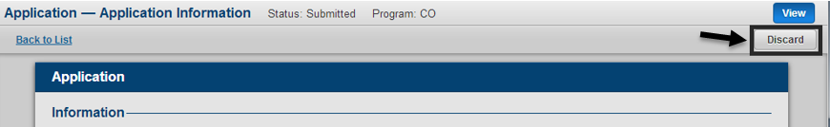

When choosing a discard an Application Information form the user will be prompted to enter comments and confirm that they wish to continue with the discard of the form as seen in the figure below.

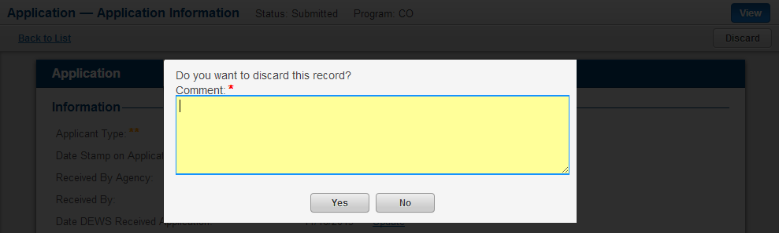

After entering comments and confirming the discard, the status of the Application Information form will change to Discarded and the user can view the comments related to the discard by clicking the icon in next to Discarded within the Status column in the Application Information table.

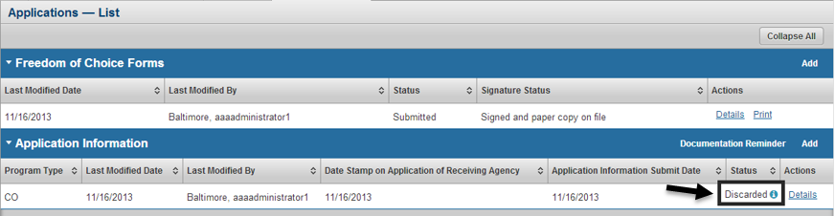

The documentation reminded PDF can be viewed within the Application module by clicking the Documentaiton Reminder link on the Application Information panel as seen in the figure below. This will open the documentation reminder checklist PDF in a separate tab within the users browser.

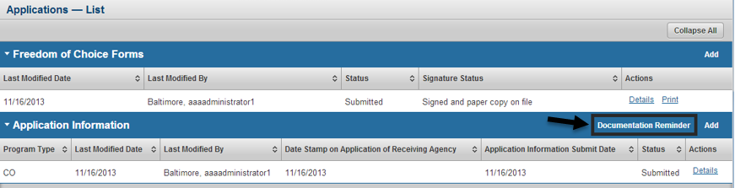

Application Information forms related to all available program types will be listed within the same table as seen in the figure below. This will give authorized users the ability to list and view information pertainingto the individual across the entire history of the client.

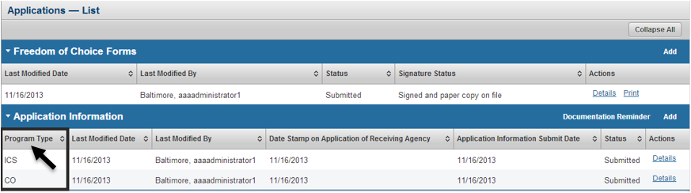

## Individual Cost Neutrality

To access the Individual Cost Neutrality module a client must first be considering Pending or Enrolled for the Increased Community Services (ICS) program. Navigate to the Individual Cost Neutrlaity module by clicking on Programs in the left hand navigations and then selecting Individual Cost Neutrality in the submenu as seen in the figure below.

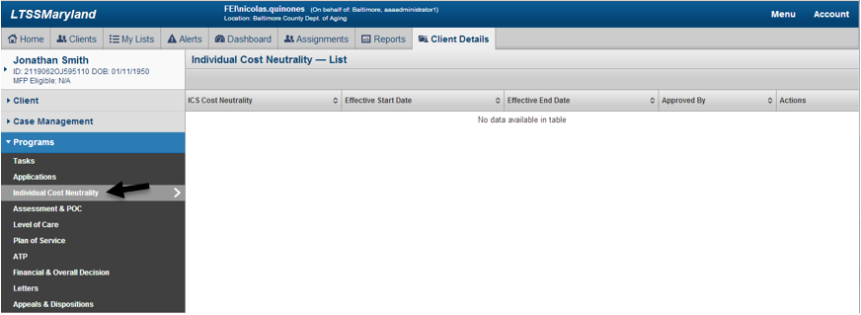

To add an Individual Cost Neutrality amount for an applicant click the Add link as seen in the figure below.

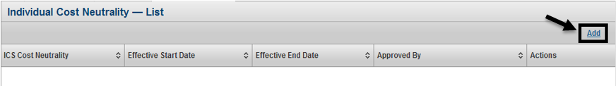

The user can then specify the ICS Cost Neutrality amount as well as the Start Date and End Date for this individual cost neutrality amount to be utilized for the client. After entering all required information the information can be saved by clicking the Save button as seen in the figure below.

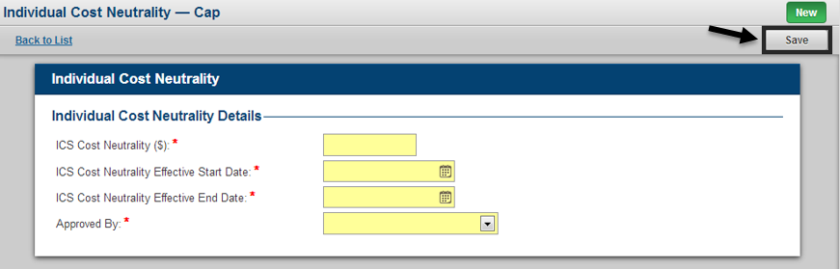

After saving the Individual Cost Neutrality, the information will be stored in the system and authorized users will have the ability to go back and update this information at any time by clicking th Edit link as seen in the figure below.

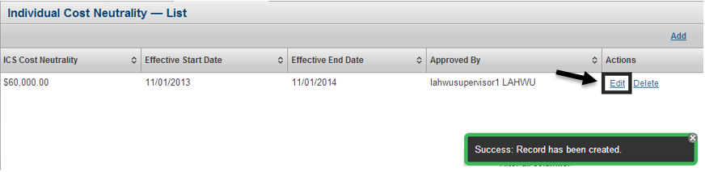

Authorized users can also choose to delete an individual cost neutrality amount by clicking the Delete link and confirming their decision as seen in the figure below.

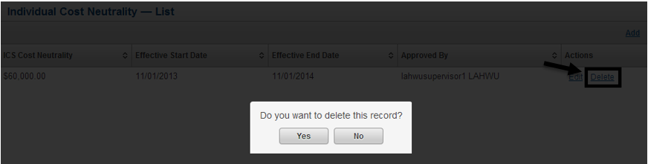

## Assessment and Plan of Care

Navigate to the Assessment and POC module by clicking on Programs in the left hand navigations and then selecting Assessment & POC in the submenu as seen in the figure below.

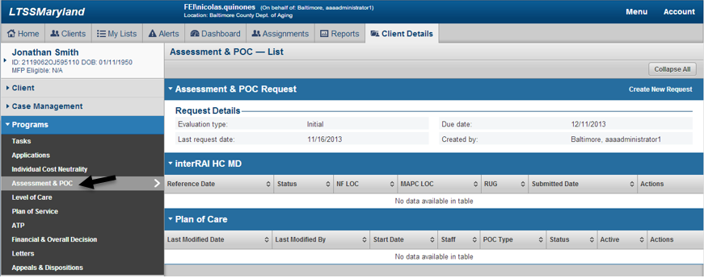

From the Assessment and POC List page authorized users will have the ability to create an InterRAI HC MD Request by clicking the Create New Request link as seen in the figure below.

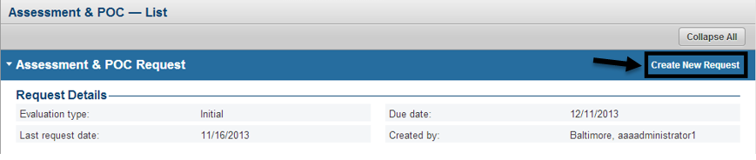

To create a request the user must specify the request evaluation type, which includes Initial, Significant Change or Redetermination. The user can also specify whether the Support Planning Agency information packet was sent to the client. If the request is submitted with this field set to Yes and the client does not have an Active or Pending Support Planning Agency, LTSS will automatically assigned the client a Support Planning Agency that will remain in a Pending status for 21 calendar days. In the event an authorized user does not manually choose a Support Planning Agency for the client, the auto assigned Support Planning Agency will become active after 21 calendar days. For further details please refer to the SPA Selection User Manual. After entering the required and optional information click the Save & Submit button to complete the request as seen in the figure below.

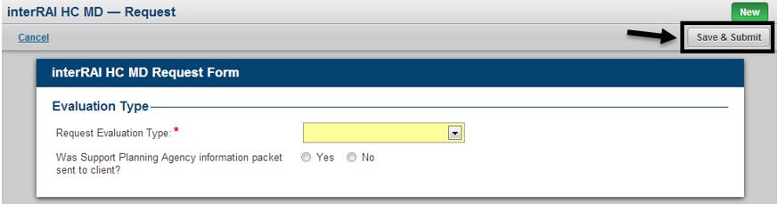

To view information related to a specific InterRAI Assessment for the client click the Summary link as seen in the figure below.

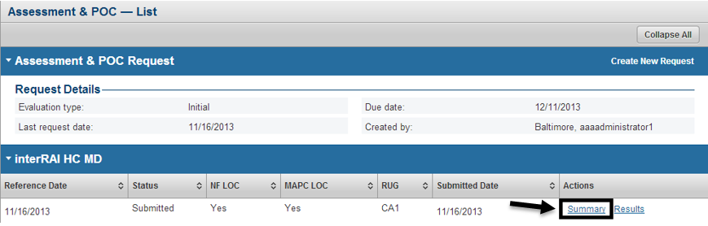

After clicking the Summary link the user will be taken to the InterRAI HC MD Summary page where they can navigate in and view specific information by section within the InterRAI Assessment.

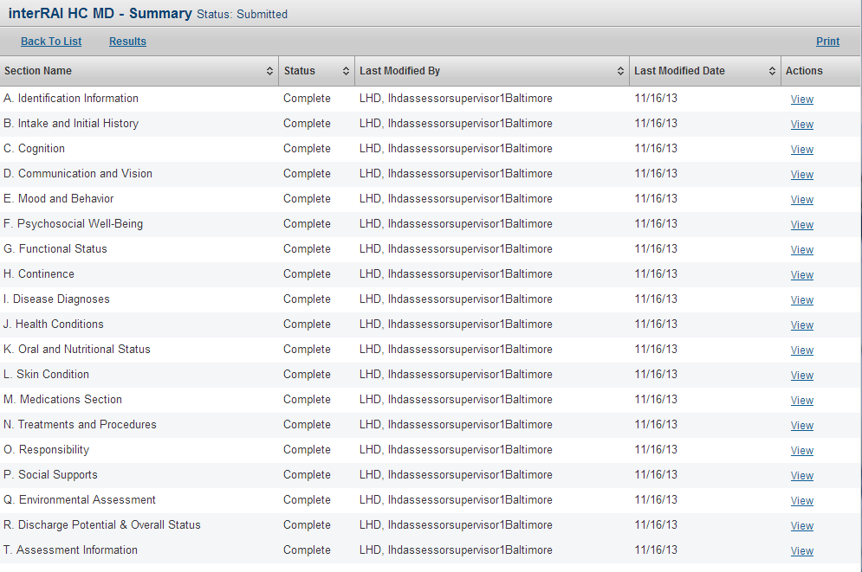

Users can also view the results page for an InterRAI Assessment by clicking the Results link as seen in the figure below.

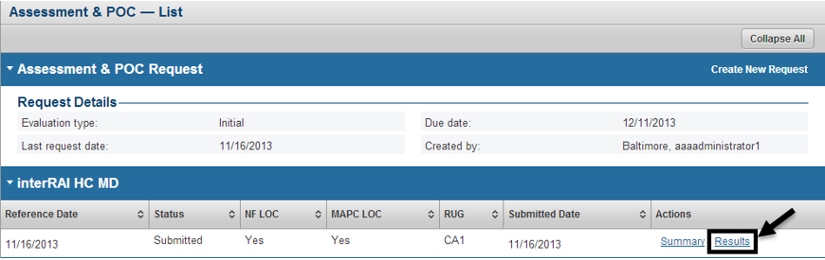

From the InterRAI HC MD Results page the user will be able to see summary information pertaining to the results from that specific InterRAI Assessment as seen in the figure below.

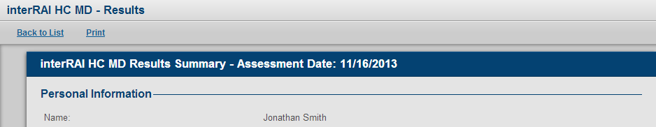

The information within a Plan of Care Form can be seen by authorized users by clicking the View link within the Plan of Care table as seen in the figure below.

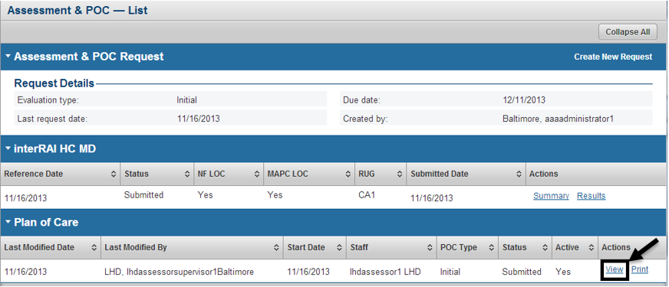

From the Plan of Care view page users can see details pertaining to a specific Plan of Care form, including information on the recommended services for the client.

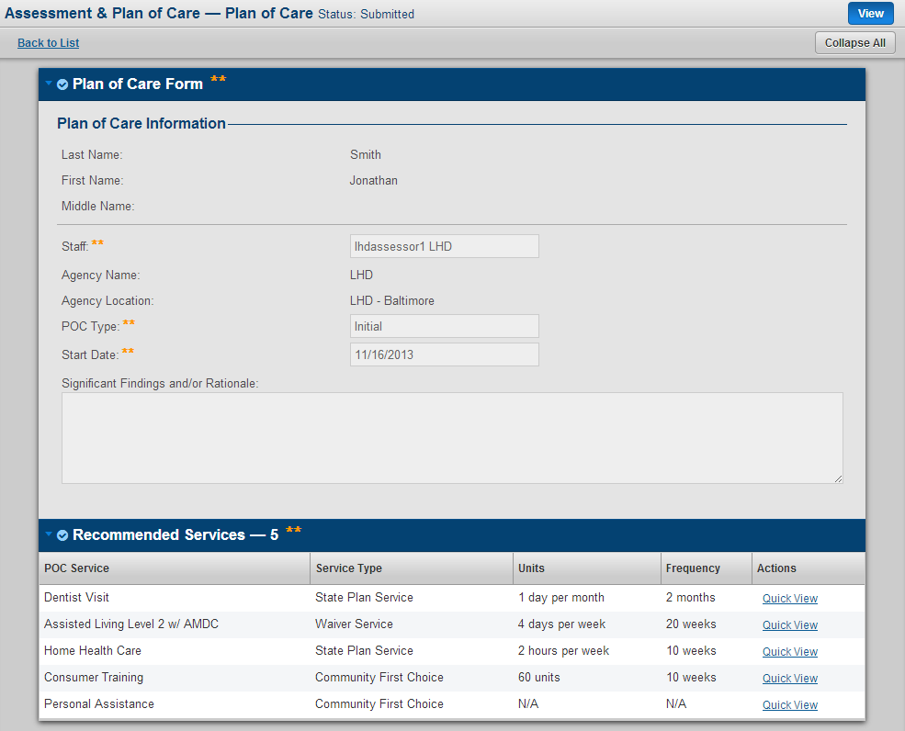

## Level of Care

Navigate to the Level of Care module by clicking on Programs in the left hand navigations and then selecting Level of Care in the submenu as seen in the figure below.

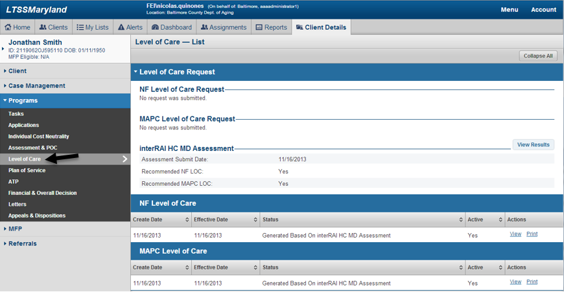

Users can view information related to the Level of Care form by clicking the View link for a specific Level of Care decision form as seen in the figure below. For further details on information in the Level of Care form please refer to the Standardized Assessment, Level of Care and Nurse Monitoring Activities User Manual.

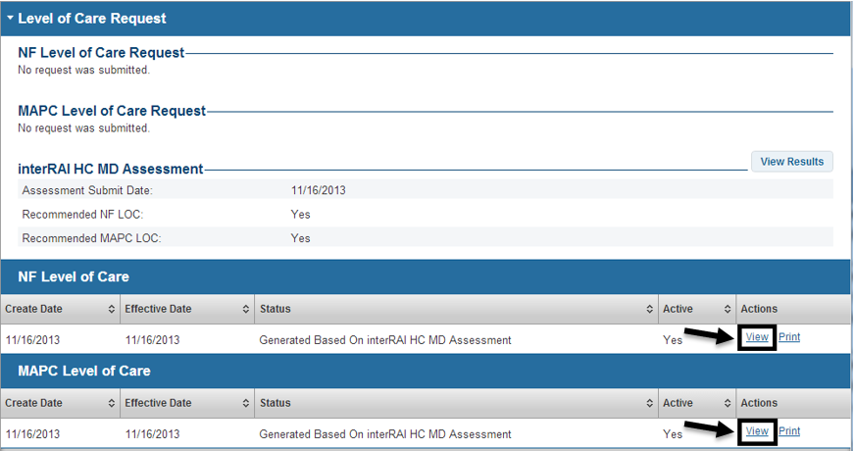

## Plan of Service

Navigate to the Plan of Service module by clicking on Programs in the left hand navigations and then selecting Plan of Service in the submenu as seen in the figure below. For further details related to the Plan of Service module please refer to the Plan of Service User Manual.

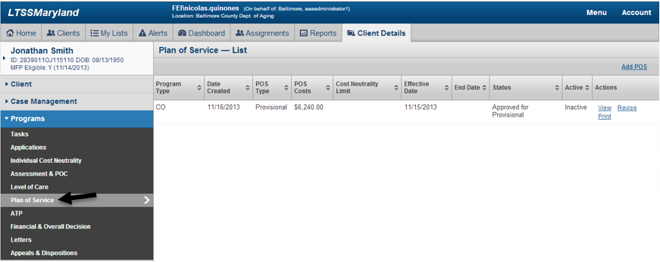

## Authorization to Participate

Navigate to the Authorization to Participate module by clicking on Programs in the left hand navigations and then selecting ATP in the submenu as seen in the figure below.

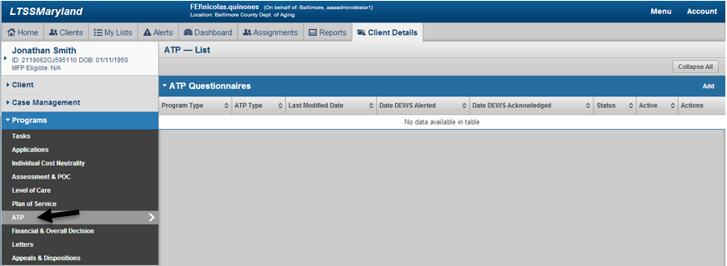

To add the ATP Questionnaire form an authorized user will click the Add link on the ATP Questionnaire panel as seen in the figure below.

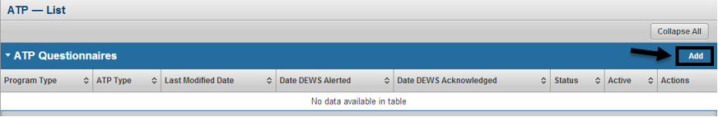

The ATP Questionnaire form can be utilized for the Community Options Waiver (CO), Increased Community Services Program (ICS), Community First Choice Program (CFC) and for the Medical Assistance for Personal Care Program (MAPC). When adding the ATP Questionnaire form the user will be prompted to select the program association as seen in figure below. Based on the Program Type selected, the available options and data within the form will vary.

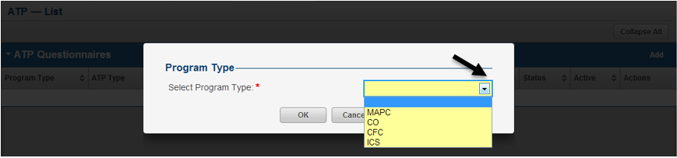

After selecting the Program Type of the ATP Questionnaire form and clicking OK, the user will be taken to the form. The first piece of information the user will need to specify is the ATP Type of the ATP Questionnaire form. This selection will drive what information is available and required within the form. Each respective ATP Type will be described in detailed throughout this tutorial. After entering all required and optional information the user can save the form by clicking the Save button as seen in the figure below.

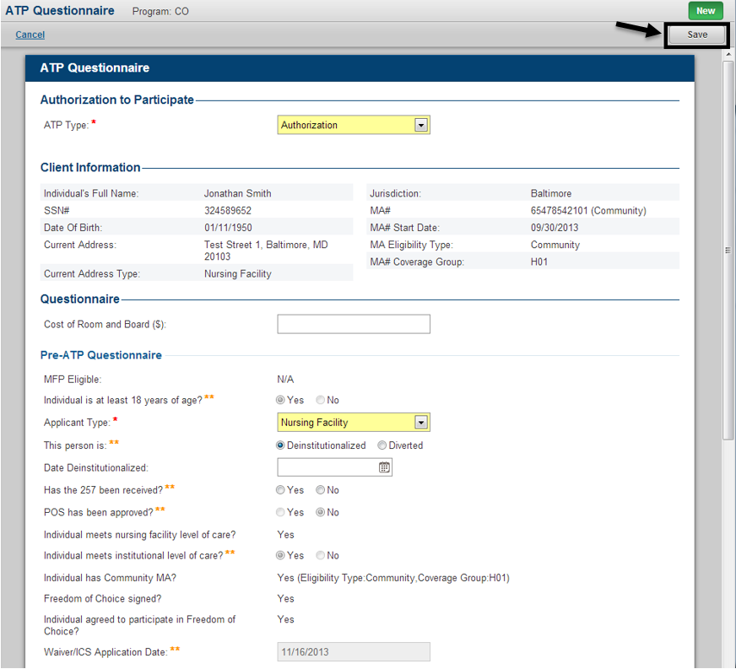

When completing an ATP Questionnaire form with an ATP Type of Advisory Authorization the only additional information the user will be required to enter is within the Sign Off section at the bottom of the form. The Advisory Authorization ATP Questionnaire is issused when a client has met Technical and Medical eligibility requirements, but has not yet found a residence in the community.

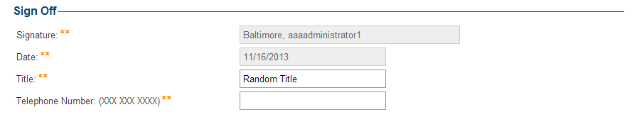

When completing an ATP Questionnaire form with an ATP Type of Authorization the Authorization section will become available within the form allowing the user to enter additional information related to the technical and medical eligibility of the client as well as information on the service effective date. In addition, the user will be required to enter information within the Sign Off section at the bottom of the form. The Authorization ATP Questionnaire is issused when a client has met Technical and Medical eligibility requirements, and is ready to be enrolled in the waiver/program pending Medical Assistance eligibility.

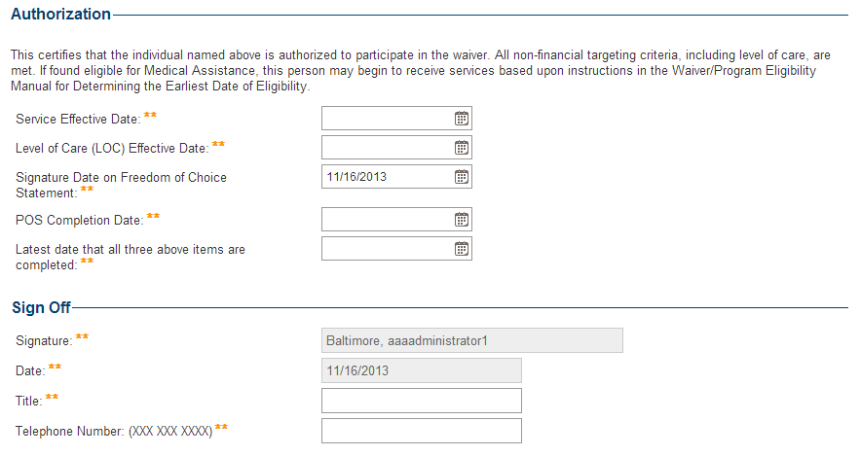

When completing an ATP Questionnaire form with an ATP Type of Denial the Denial and Reason(s) for Denial to Participate section will become available within the form allowing the user to enter specific information on why the client is being denied access to the waiver/program. In addition, the user will be required to enter information within the Sign Off section at the bottom of the form. The Denial ATP Questionnaire is issused when a client has been deemed not to meet the criteria necessary to participate in the waiver/program.

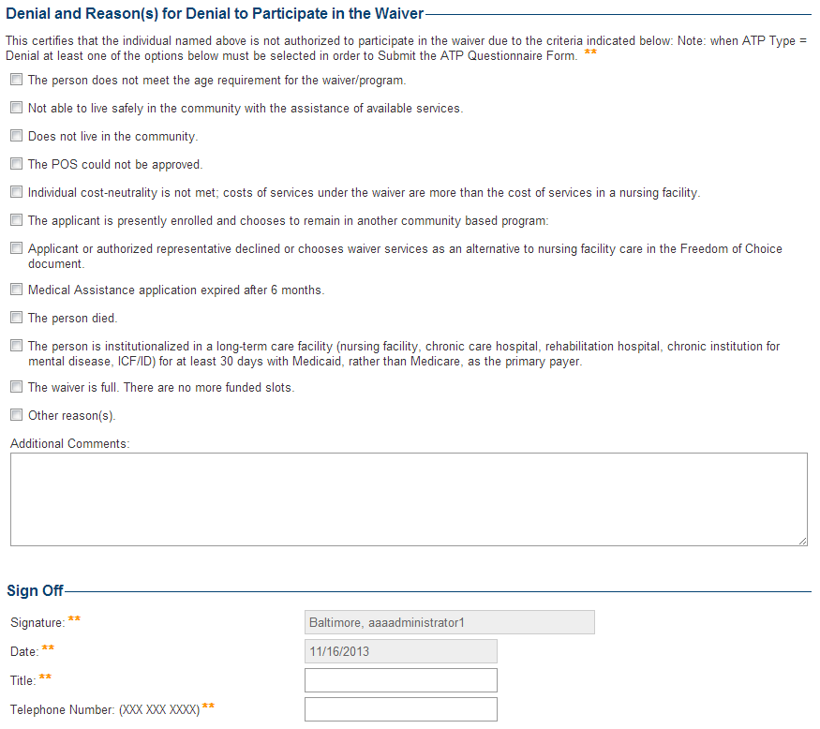

When completing an ATP Questionnaire form with an ATP Type of Denial Over-turned the Authorization Denial Overturned section will become available within the form allowing the user to enter specific information on why the client is being given access to the waiver/program based on an Appeal decision. In addition, the user will be required to enter information within the Sign Off section at the bottom of the form. The Denial Over-turned ATP Questionnaire is issused when a client was previously denied access to a waiver/program and then appealed that decision and successfully won that appeal in order to gain access to the waiver/program.

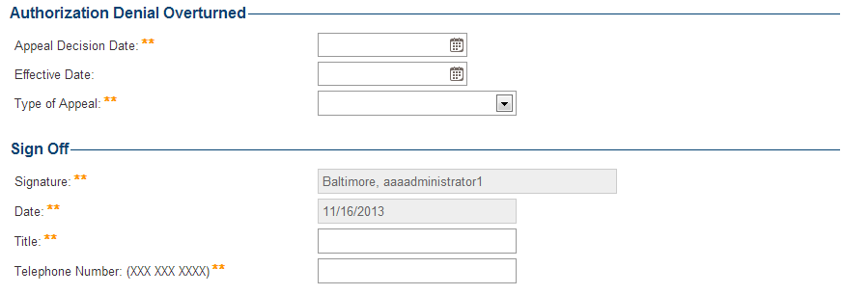

For the Community First Choice (CFC) and Medical Assistance for Personal Care (MAPC) programs, the ATP Type of Advisory Authorization does not exist. These programs will only have access to the Authorization, Denial and Denial Over-turned ATP Types.

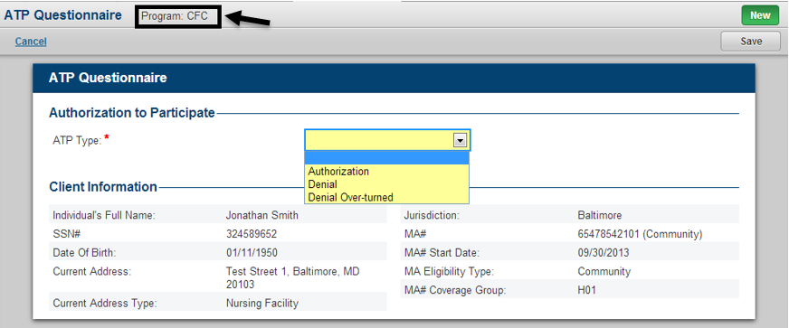

After selecting the appropriate program type and ATP Type for the ATP Questionnaire and filling out the required and any optional information and saving the form, the user will have the ability to go back and edit any necessary information as long as the form is in a status of In Progress by clicking the Edit button as seen in the figure below.

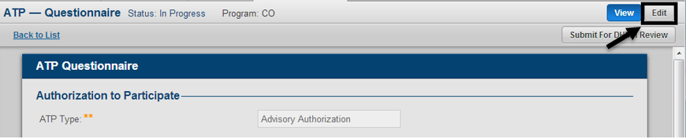

Once the user has completed entering information for the ATP Questionnaire, they can submit that ATP Questionnaire to be reviewed by DHMH by clicking the Submit For DHMH Review button as seen in the figure below. This ability will only be available to authorized users outside of the DHMH Agency. If it is an authorized DHMH users working with an In Progress ATP Questionnaire, the form can be submitted directly and does not need to go through the review process.

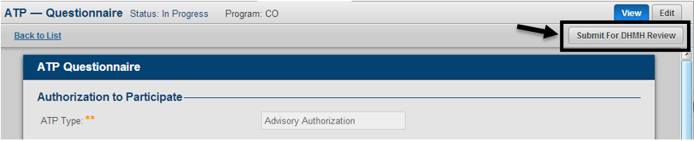

After submitting the ATP Questionnaire for DHMH review, the Status of the form will change to Pending DHMH Review as seen in the figure below. Authorized DHMH users will have the ability to review and make any necessary edits to the ATP Questionnaire by clicking the Edit button as seen in the figure below.

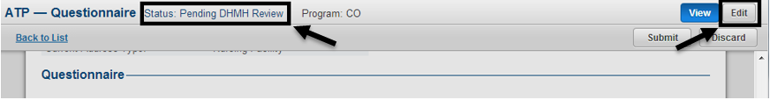

When a DHMH user is reviewing and editing the ATP Questionnaire, they will have access to the DHMH Sign Off section of the ATP Questionnaire. After filling in all optional and required information, the user can save their changes by clicking the Save button as seen in the figure below.

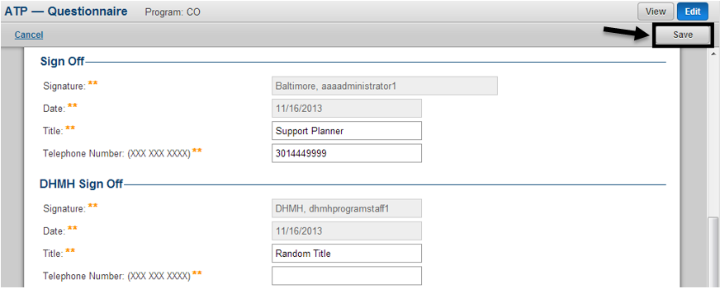

Once DHMH has completed their review process of the ATP Questionnaire, the form can be submitted by clicking the Submit button as seen in the figure below.

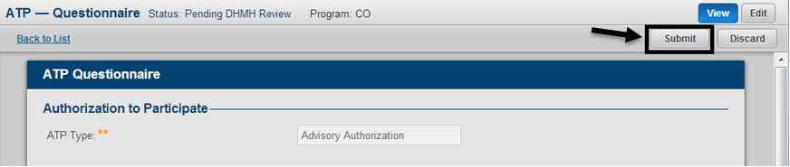

After submitting the ATP Questionnaire the form will appear in a Submitted status in the ATP Questionnaire table as seen in the figure below. A submitted ATP Questionnaire can be viewed, but no additional edits can be made.

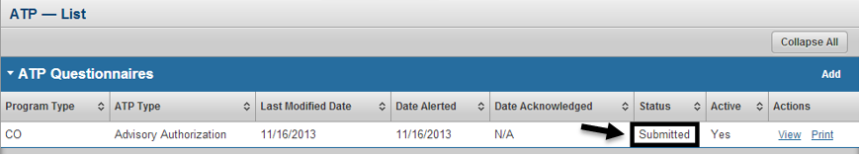

Authorized users will also have the ability to discard an ATP Questionnaire by clicking the Discard button as seen in the figure below. When discarding an ATP Questionnaire the user will be prompted to enter comments and confirm their decision.

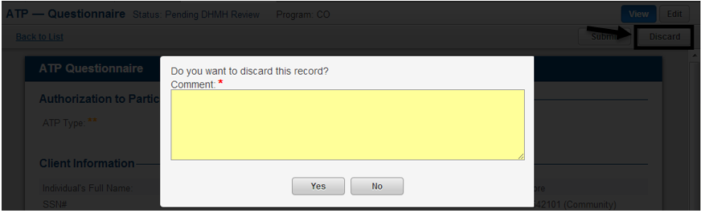

After discarding the ATP Questionnaire the form will appear in a Discarded status in the ATP Questionnaire table as seen in the figure below. The discard comments for an ATP Questionnaire can be viewed by clicking the icon under the Status column next to the word discarded as seen in the figure below.

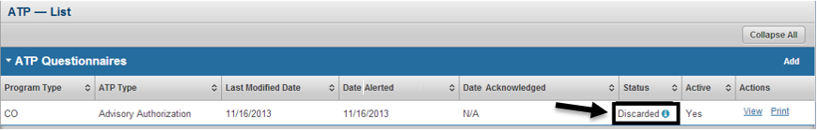

An ATP Questionnaire can also be printed by clicking the Print link under the actions column as seen in the figure below. This will open a PDF of the document in a separate tab in the users browser.

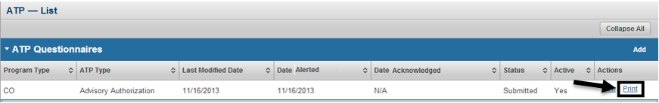

## Financial and Overall Decision

Navigate to the Financial and Overall Decision module by clicking on Programs in the left hand navigations and then selecting Financial and Overall Decision in the submenu as seen in the figure below.

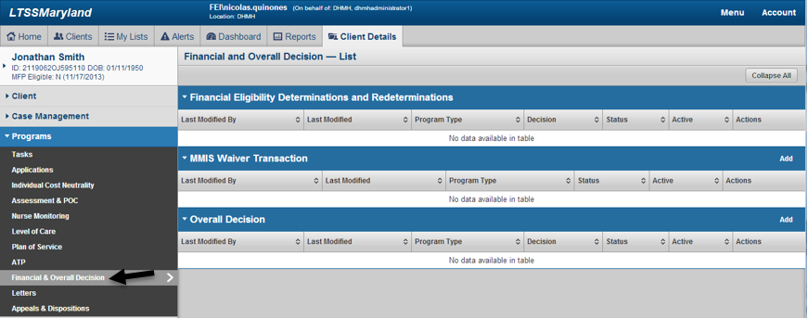

From the Financial and Overall Decision List page, the user will be able to view information related to the Financial Eligibility Determination and Redetermination Form as well as the Overall Decision Form by clicking the View link as seen in the figure below.

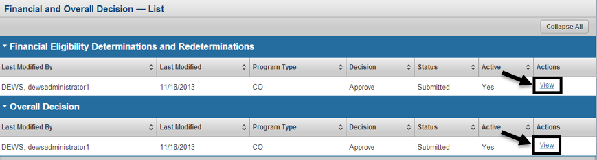

## Letters

Authorized users can navigate to the Letters module by choosing Programs in the left hand navigation and then selecting Letters under the submenu as seen below. From the Letters List page the user will be able to view all letters across the history of the client for CO, ICS, CFC and MAPC. To view the details of an individual letter click the View link under the actions column for the specific letter as seen in the figure below. Authorized users can also go to the manage page for a specific waiver/program for letters by clicking the Manage link. From the manage letters page the participants assigned Support Planner will be able to acknowledge letters.

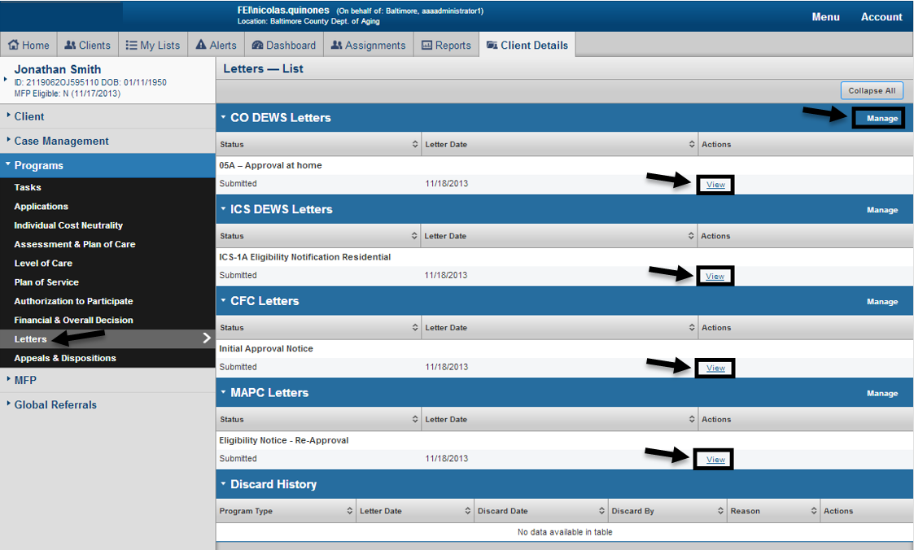

## Appeal and Disposition

Navigate to the Appeal and Disposition module by clicking on Programs in the left hand navigations and then selecting Appeal and Disposition in the submenu as seen in the figure below. To view an appeal record, click “summary” link of the record. For further details related to the Appeal and Disposition module please refer to the Appeal and Disposition User Manual.

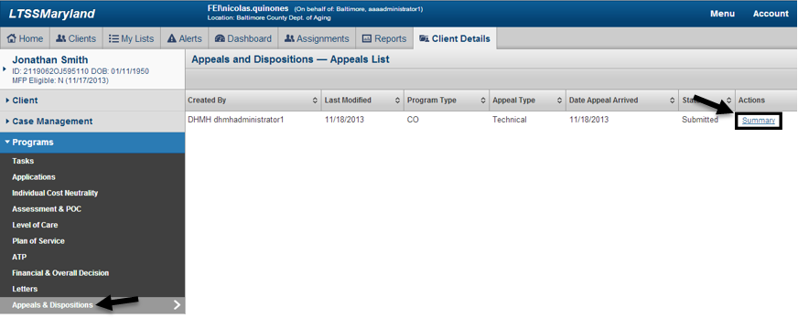

## Case Notes

Navigate to Case Notes for a participant select Case Management in the left navigation and then click Case Notes in the submenu as seen in the figure below. A pop up window will appear which will show the user case notes for the participant as well as provide the ability to add new case notes. Each case note will have an associated Waiver/Program. After entering the required and optional information click the Add Case Note button to add the case note to the participant. When case notes are added, LTSS will store the Agency of the user that added, the name of the user that added the note as well as the date the note was added. Case Notes can also be printed by clicking the Print button as seen in the figure below. Agencies will only be able to view case notes entered by other agencies for which DHMH has granted them access to see through the Case Note ACL module in LTSS.

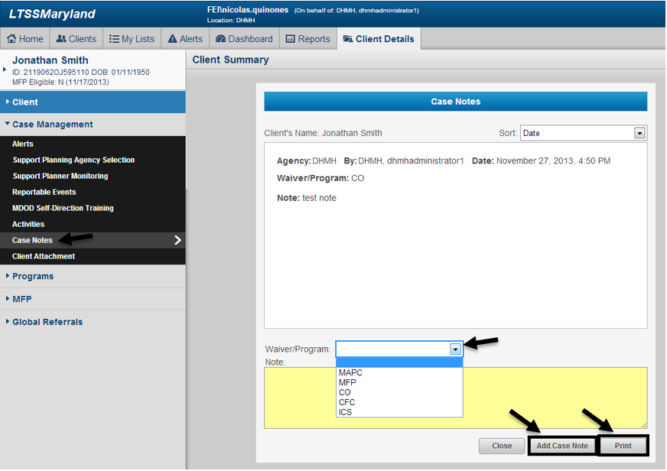

DHMH Administrators will have the ability to manage Case Notes ACL by going through Menu, Administration and then clicking Case Note ACL as seen in the figure below.

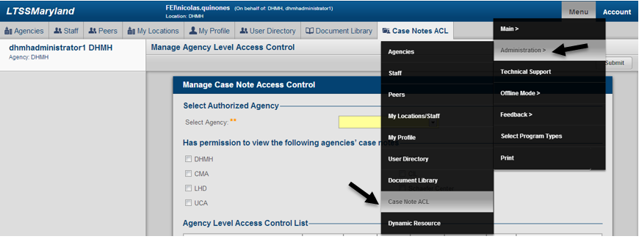

After clicking Case Note ACL under Administration, staff with the role of DHMH Administrator can manage what agencies can view case notes enter by other agencies. This is a system wide management and not participant by participant. To manage the ACL for case notes for a specific agency, select that agency in the Select Agency dropdown as seen below. Then by using the checkboxes, the user can select what agencies will be able to view case notes entered by staff associated to the agency in the Select Agency dropdown. To save the changes, click the Submit button as seen in the figure below. DHMH Administrators can edit the ACL access for an agency at any time by reselecting that agency and following the steps mentioned above.

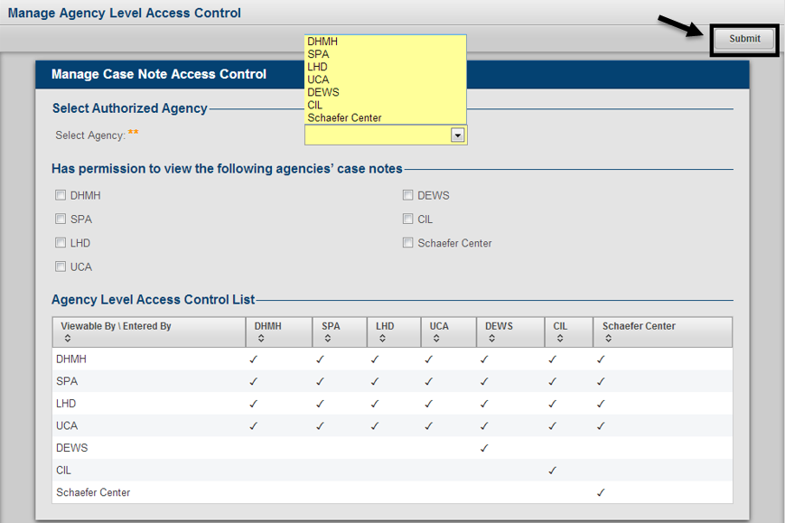

## Activities

Navigate to the Activity List page by selecting Case Management in the left hand navigation and then clicking Activities under the submenu as seen in the figure below. The Activity List page will be produced where authorized users can view activity information for the participant. Support Planning users will be able to filter for activities by specifying a Start Date and End Date to look for specific dates of activity. The user can also filter by a specific staff member that has entered activities for the participant or by specific Activity Statuses, which will be discussed further in a later tutorial in this manual. By default LTSS will show users all activities in a Status of New or Sent for which they have permissions to view.

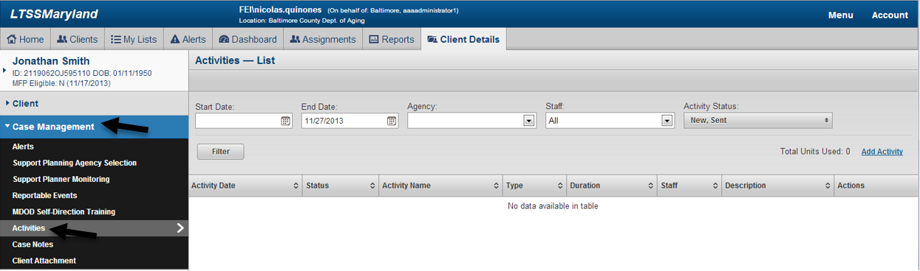

From the Activities List page, authorized Support Planning Agency users will have the ability to add new Support Planning activities for the client by clicking the Add Activity link as seen in the figure below.

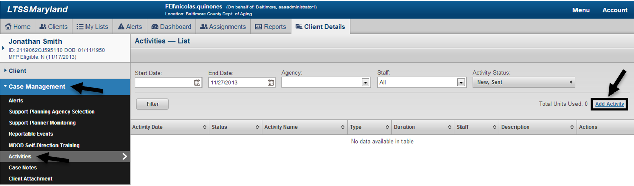

After clicking Add Activity, the user will be able to specify the details for the Support Planning activity they wish to add to the client. Any staff member associated to a Supports Planning Agency will be able to access this page, but users will only be able to add activities for a date of activity during which their Suppport Planning Agency was actively assigned to the client. After entering all of the required information, the user can save the activity by clicking the Save button as seen in the figure below. If the user wishes to save the activity and add another activity, click the Save & New button as seen in the figure below. If the user wishes to cancel adding an activity, click the Cancel button as seen below.

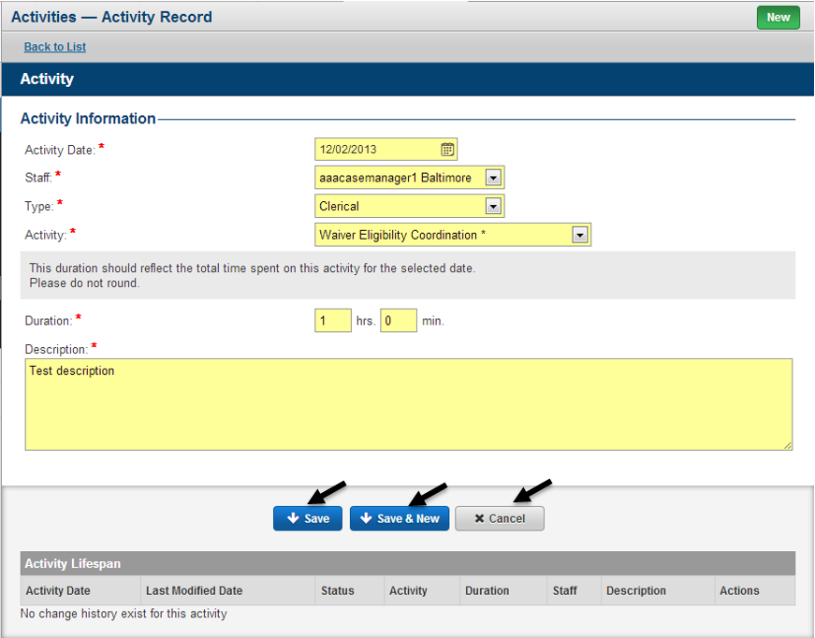

When saving an activity, the user will be taken to the view page for that activity, where they will have the ability to edit or delete the activity as long as it is in a status of new. To edit an existing activity, click the Edit link as seen in the figure below. To delete an activity, click the Delete link as seen in the figure below.

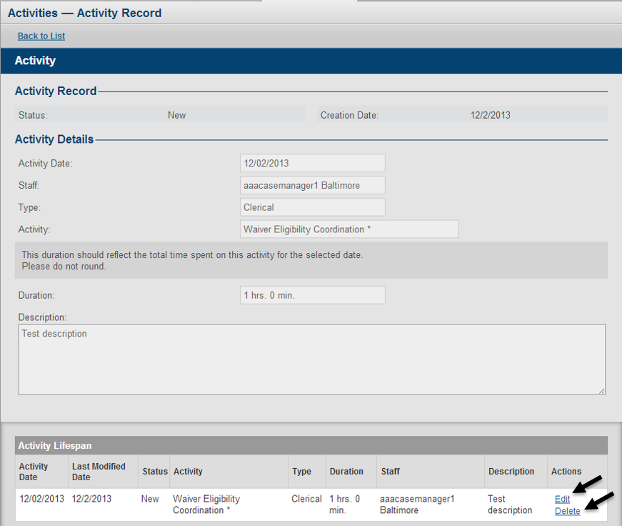

For activities in a status of sent, rejected or paid, authorized users will have the ability to adjust an activity by clicking the Adjust link as seen in the figure below. Support Planners will not be able to adjust their own activities, as this functionality to reserved for administrators, supervisors and billing staff.

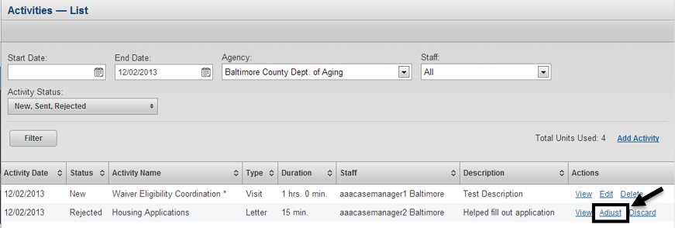

In order to add an adjustment for an activity, the user will be required to modify at least one of the fields related to the activity. Until a change has been made the Add Adjustment button will be deactivated. Once a change has been made, the user can save their adjustment by clicking the Add Adjustment button as seen in the figure below.

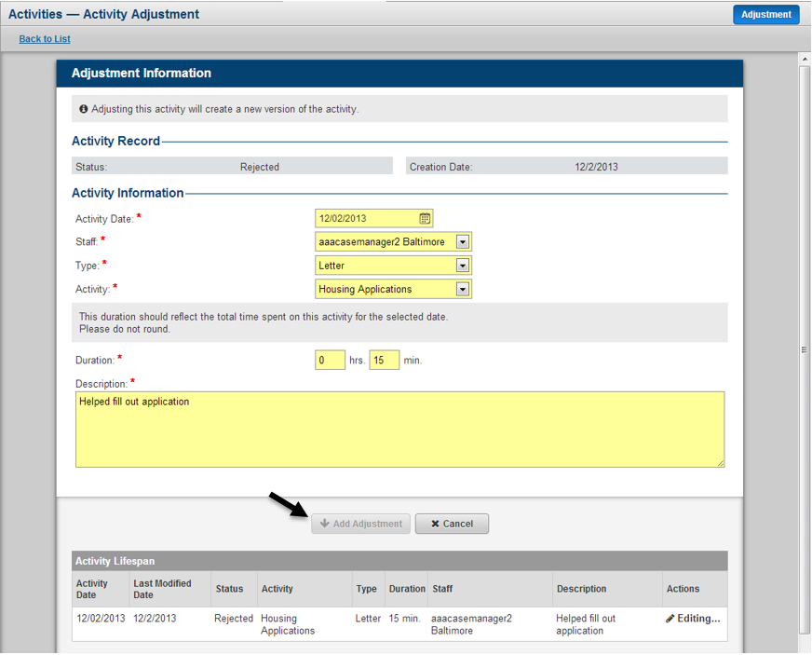

When the user has added the adjustment, they will be taken to the view page and the user will see a new record within the Activity Lifespan table. The new adjusted record will be stored at the top of the table and the user can continue to work with this record until it is once again sent to MMIS through the claims process. The user can make additional edits to their adjustment by clicking the Edit link as seen below. The user can also choose to unadjust the activity by clicking the Un-adjust link as seen in the figure below.

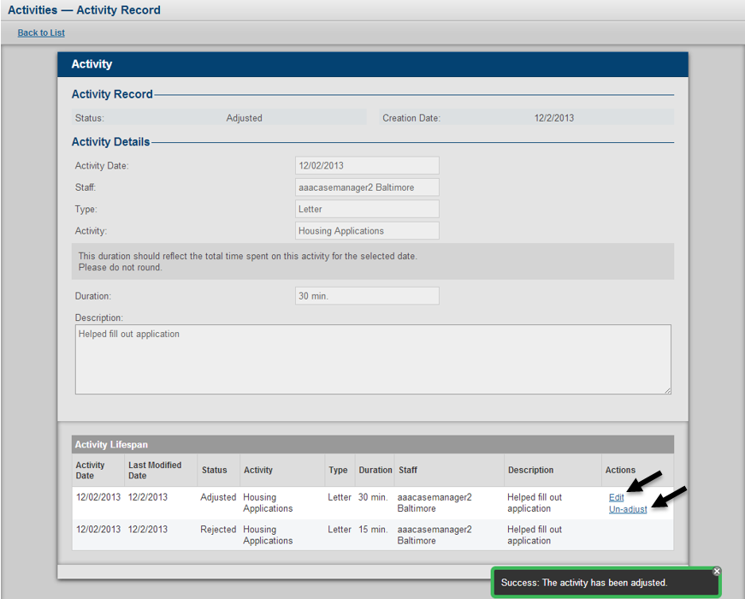

When choosing to unadjust an activity, the user will be prompted to confirm their decision. The unadjustment process acts as a delete of the adjusted record, meaning the activity will revert back to its previous state. Only activities in a status of Adjusted can be unadjusted.

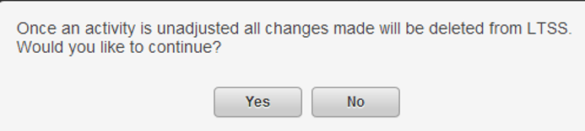

Authorized users will also have the ability to Discard an activity that is in status of sent, paid or rejected. To discard an activity click the Discard link as seen in the figure below. The user will then be prompted to enter comments and confirm their decision.

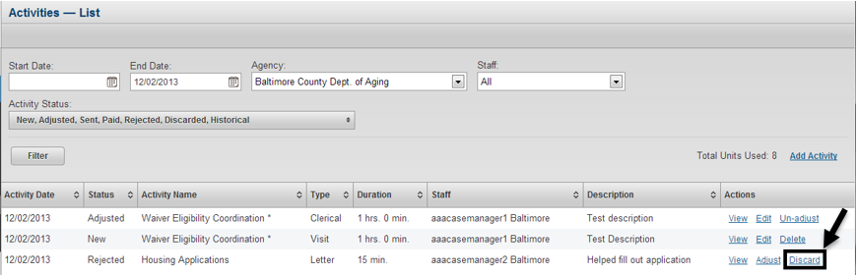

Users can also view existing activities by clicking the View link as seen in the figure below.

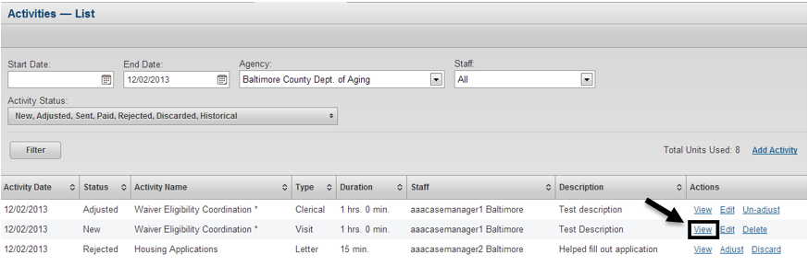

# Appendix

## Waiver/Program Connections with Other Modules

|  |  |
| --- | --- |
| **Module** | **Details** |
| Application | If a client comes through MFP and gets a submitted Options Counseling Application Assistance Form indicating application assistance was provided for CO, LTSS will create both a submitted Freedom of Choice Form and Application Information Form for the client. |
| Individual Cost Neutrality | The ability to add cost neutrality amounts will only be available if the client is considered an ICS applicant. |
| Plan of Care | A Plan of Care Form cannot be created/edited unless the client has a submitted InterRAI Assessment. |
| Level of Care | A Level of Care Form cannot be manually added unless the client has a submitted InterRAI Assessment. |
| Plan of Service | A Plan of Service cannot be developed for the client unless the client has an assigned Support Planning Agency and a submitted Plan of Care Form. |
| Financial and Overall Decision | An Overall Decision Form for CO or ICS cannot be created until the client has a submitted Financial Eligibility Determination Form. |
| An Overall Decision Form for CFC or MAPC cannot be created until the client has a submitted ATP Questionnaire. |
| Appeal | An Appeal Form cannot be created for the client unless they have a submitted Overall Decision Form for the corresponding waiver/program they are trying to create the appeal for. |
| Activities | Support Planning activities can only be adding for a date of activity during which the agency adding the activity was assigned to the client from the Support Planning Agency Selection module. |